Introduction

Set aside distractions
Stretch
Set intentions
Three part breath

The Pot Belly Breath, is the most important spiritual and psychic tool that you could ever learn. It is the breathing technique to start any technique and the one to end all techniques.
If one learns any breathing technique it is this one.
Described earlier, the main points are:
sitting comfortably and erect.
Good posture and having ones chest comfortable but open to allow simple diaphragm breathing.
Slow comfortable and steady breathing.
The count is a mental exercise as well as the focus on pure breathing. The count is the same
Breathe in for a count of 4
Hold the breath for a count of 4
Breathe out for a count of 4
Then Hold for a count of 4
That is a 4 square, pot belly breath.
As you relax it will be easier to extend the count.
Use the extended count only if you the outbreath is relaxed steady and not forced. If you do control it relax and be aware of it. There is no need for suddent exhales, or allowing frustration color how you breath. Observe, steady, choose and be comfortable. Every bit of discipline one uses exercises their mind, their will and your ability to go further. Use it as a tool.

Emotional balancing exercise

One round of breathing you do the following:

Breathe out from your bladder into your kidneys
Breathe into your liver from your kidneys,
Breathe out from your liver into your heart,
Breathe into your spleen from your heart,
Breathe out from your spleen into your lungs,
Breathe into your kidneys from your lungs,
Breathe out from your kidneys into your liver,
Breathe into your heart from your liver,
Breathe out from your heart into your spleen,
Breathe into your lungs from your spleen,
Breathe out from your spleen into your kidneys,
Breath out to your bladder from your kidneys.

Repeat 6 more times

Reverse Abdominal breathing or Dragon Breath

Sit straight
Start inhale, contract belly, push energy up spine
Lengthen and straighten spine
At top of inhalation, raise energy up neck and into head.
On exhale, move energy down front
At bottom of exhale, collect energy in abdomen.

Reverse abdominal breath.
Dragon, Triple Burner, Hora, micro-cosmic breathing, of various names are essentially the same technique with different names.
If anyone is to practice magic of any kind, this absolutely for your health, your sanity, control of magic and body along with spiritual awareness.

We start with a Mulabandha lock, this is where you clinch your Perineum and tilt your pelvis up this breath starts with your lower abdomen out and your upper abdomen in.
You start your in breath by tucking and your lower abdomen and imagine the energy going up the outside of your spine up your back filling in your upper abdomen and then your lungs to which point the energy reaches to the top of your head. You tilt your head slightly back. Then you reverse the process exhaling with your lungs first bringing the energy down through the front of your face, slowly, and as you empty your upper abdomen. The energy is going down through the front of your body back down to your perineum. And then you stick out your lower abdomen, bringing the energy up into your Dan Tien. The Dan tien is a space and an inch or two below the navel centered in your lower abdominal cavity. This is where you store your astral energy. As you practice this breathing energy will be coming in through your hands and feet and head and migrating to these central vessels. These central vessels are called the governing governing Meridian and the conception Meridian. As you cycled this energy it becomes homogenized it gets attuned to your body. This process is is repeated until the area gets warm, or until you are fatigued from the breathing exercise. This breathing exercise exercises, the organs. It squeezes the toxins and sometimes it is difficult to get a full breath. What is important is the focus of the energy during what is called the microcosmic cycle up the middle of the back, up to the top of the head down through one's front of their face and down the front of their thorax and abdomen. At the last of the outbreath stick the lower abdomen out.
Store the energy by exchanging your lower abdomen with your middle of the stomach. Tuck in the lower abdomen and extend your middle abdomen out moving the energy up to and behind just below your navel. You are sucking the energy up into your lower abdomen, the Dan Tian.

Sometimes when the energy comes down through one's face, you feel it's split up and go around one's lips. Sometimes you feel the energy going through your nasal cavity to your soft palate and through your tongue. Through these exercises it is important to keep your tongue to the roof of your mouth.

You can augment this exercise by pausing the inhalations and exhalations at each surface chakra point. When halted to circulate the energy at that point, 3, 7 or nine times left then right. And proceed to the next point. Of course this depends on your skill at meditation and self control of your breathing. This is for advanced practitioners. This process does two things. First this would collect astral energy. Second, it helps it to adjust and harmonize this energy to yourself and to your body. Why this is important is because the astral energy for you to be healthy, must be attuned to you. How many energy workers from magical practitioners have you noticed that has suffered some sort of major medical malady? The conditions seems to be chronic persistent, and ultimately draining of the life force. This is because in many magical practitioners follow wrote and revealed procedures and processes as they were taught. One ends up using their energy and has not learned how to cultivate it or maintain it. Nor are they able to understand their bodies, spiritual and internal astral processes. The absolute importance of meditating to the point of where you have a calm mind is crucial. This is so that your energy is not attached to frustrations or connections with things external to you that cause you grief, problems or any negativity. If you cycle your energy, and homogenize your energy with this negativity, you are binding it to yourself. This is not what you want to do. This is why it is so crucial to meditate properly before the sessions.

So where does this energy come from? We come in contact with it all the time we have a natural flux of energy going in and going out. Do what you can studying the various traditions and learn about how this energy flows in through the day and cycles through the day. What is important is learning to have conscious control over this.
This is why people go to mountains or other sources of nature to have access to clean and natural energy not cluttered or polluted from people.

There are several other techniques for energy breathing. These are called Bell breathing, and five point breathing.

There are two types of Bell breathing the first is Tibetan Bell Breathing. Tibetan L. breathing starts with breathing out reaching with your senses attaching to energy. And as you breathe in collect that energy to yourself.

Daoist Bell breathing starts breathing in, yet reaching out and connecting with energy. Then as you breathe out, you focus that energy inward. There is two places to focus this energy. The first place is you Dan Tien. The second place as the energy is coming into your body. You push it into your bones and into your skin and into your organs.

The important thing about this type of energy collection is to be aware of the energy that you are bringing in. It is very important to be aware of the environment and energy as it relates to your physical body and be sure that the energy goes into the organs that it is harmonious with it. So this takes some traditional studying.

The five points breathing technique. You learn to breathe in through your hands and feet in the top of your head. This where it is also useful to know the acupuncture meridians, the energy type and the organs to which these meridians are connected to from your feet, hands and head. Ideally, you breathe in your hands feet and head and out your hands feet and head. This technique requires to the think of your whole body as a means for breathing energy. For example, when you breathe with your arms, gently reach out and grab the energy. And as you pull your hands in feel the energy coming in the same thing with your feet as you lower your pelvis and bend your knees and feel the energy coming in as you breathe in. And when you breathe out as you extend your legs.

This is a useful technique also to all allow negativity to drain out as if you are your breathing it out. You can let go of negativity and have it seep out the palm of your hands and the bottom of your feet. They're several authors that a good magician should become acquainted with the first is Mantak Chia and the second is Jwing-Ming Yang. The first understands and teaches iron shirt Kung Fu and internal alchemy using the microcosmic breath. Mantak Chia also teaches stretches, and other internal breathing techniques to clear strengthen and inform the body of all the energy paths. Dr. Yang has probably the best by far books on Qi Gong. He also teaches Yang style tai chi. This ties in Daoist breathing, along with martial arts of tai chi.

Connect with elements
Two sections, divided at bottom of rib cage
Lower first – Emotional body
Upper - Mental

Seed vowels
Say | area | Attitude and nature of the sound. | Thought and process with the object of focus
Ah | diaphragm | Inside your whole body. Your internal resonance | The expression of the emotional and physical self. The Element is within you.  How you express yourself with in
Oh | Upper abdomen  Solar Plexus | Your resonance with the world around you. | The presence of self in the world around you. Connect with element
Oo | Lower abdomen, Just below and behind the navel | How the energy is exchanged or a reciprocal energy with the world | Apprehension, the dynamic of energy and relationships of the element from with out and with in.
Uh | Root of the spine, the perineum | The energy is integrated into your being | Integration, the energy of self and the world is mixed and made part of yourself.
Rr Ll | This is right and left spiraling  Either or both sounds help in causing the vowels to resonate. | Right spiral from the earth brings earth energy up. into you.  Left spiral energy of the pushes it away.  Left spiral energy from the sky brings energy down into you. Right spiral energy pushes sky energy away. | This is not separate from the chant nor is it a primary focus.  This helps to be aware of how energy ebbs and flows and each element has these two natures. Each gives structure or order, chaos or entropy.
Eh | Heart sternum connected with the diaphragm | This energy vibrates or resonates in the world. The conscious connection that you have in the world. | How you are already connected to the element.
Ay | Throat | Reaching out, choosing to vibrate and connect to parts of the world | Connect with element, vibrate with your object of focus.
Eye | Forehead | Choosing to identify with your focus, vibrate with the element as one. | Comprehension of the element, Identity one with the element.
Ee | Crown to solar plexus | Through top of head, down to abdomen. | Integration, the structure and the energy are brought consciously into ones being.

Elements Color Earth/Yin Yang/Heaven
Organs Organs
- Earth yellow Spleen Stomach
- Metal white Lungs Large Intestines
- Water black Kidneys Bladder
- Air blue Brain Eyes ( my addition)
- Wood green Liver Gall Bladder
- Fire red heart/pericardium Small intestines/triple burner

The following is a chant that overlays a few concepts over the relationship chant.

Every two lines has a focus on the relationship vowel.
The root words are concepts, Brub pronounced Broob, Laugun pronounced La oo goon, and Murr like purr with an M.

Brub takes something that you apprehend and turn it to do something else. R and u (oo) indicate turning and change. It is all about change. B is a sound that relates to the earth and the world you know. B starts forcefully but is soft as compared to p. And it ends forcefully but soft as compared to p.

Laugun is about flow and participating with the nature of the things as they are.
L and La is like law it is about following the current pattern, the pattern can be as soft as the flow in lakes and streams. A and u is about taking oneself into the rhythm of U. G guttural as in golf is soft it’s a choice of giving to the pattern U and N where N is a need.

Murr sounds like Myrh but think of it as a point of reflection a mirror if you will. More then having a reflection of your self in the world around you, then you are no different than the world, but you too are a liquid mirror, observing, reflecting on the world.

These are all internal conscious choices. The choices are change, participating in what is, or observing it for what it is.

Each has the ending of the relationship vowels.
The Eh and Oh are articles and prepositions. The indicate Female (Eh) and Male (Oh) with the aspirate H as H is whispered. The purpose is that the relationship of expression given space in the H to manifest.
Eload Conscious expression and being internalized in directed being.
Eloat Conscious expression and being internalized in directed conscious activity.
Alliat Conscious expression internalizing being consciously directed.
Alliad Conscious expression internalizing consciousness with directed being.

Reflect on these concepts only when the other concepts flow in your consciousness. They are different.

EL as pronouncing the letter L, O as in Oh, a as in ah
All as where A is sounds like the a in Ma, I as in ee, and a as in ah

The male triplets end in s. It brings the energy in with intention otherwise without it, the energy filling your being evenly.

As you practice, you will notice that the relationship vowels and the nature of the d and t are balanced with nature of focus and being, consciousness and awareness. Female and Male both roll through the whole body in conscious and being, awareness and focus.
The Male balances the nature of the 3 female, and female balances the nature of the 3 males and the roles reverse.

Then the last two lines takes the these 4 balance beings 2 female and 2 male, and the added vowels take this higher self balance of being and communicates it out and around you. This adds the consciousness out and beyond your being, with the pattern that you have learned.

One dragon breath for each, or the triplet, and one dragon breath is used for the balance being.
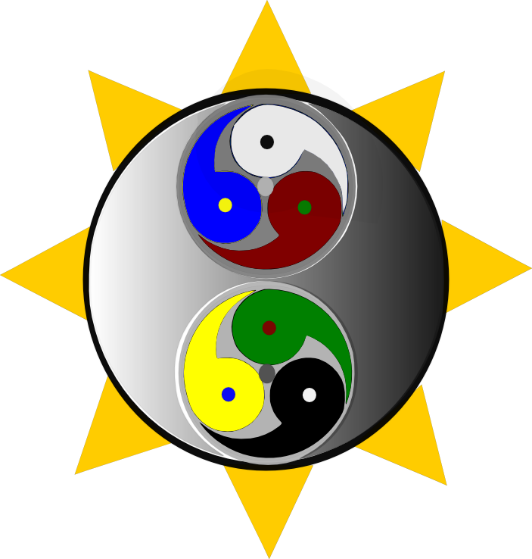

Eh Brubeh, Eh Lauguneh
Eh Murreh, Oh Eload
Eh Brubay, Eh Laugunay
Eh Murray, Oh Eload
Eh Brubeye, Eh Lauguneye
Eh Murreye, Oh Eload
Eh Brubee, Eh Laugunee
Eh Murree, Oh Eload
Oh Brubahs, Oh Laugunahs
Oh Murrahs, Eh Alliat
Oh Brubohs, Oh Laugunohs
Oh Murrohs, Eh Alliat
Oh Bruboos, Oh Laugunoos
Oh Murroos, Eh Alliat
Oh Bruburs, Oh Laugunurs
Oh Murrurs, Eh Alliat
Oh Brubehs, Oh Laugunehs
Oh Murrehs, Eh Alliatd
Oh Brubays, Oh Laugunays
Oh Murrays, Eh Alliad
Oh Brubeyes, Oh Lauguneyes
Oh Murreyes, Eh Alliad
Oh Brubees, Oh Laugunees
Oh Murrees, Eh Alliad
Eh Brubah, Eh Laugunah
Eh Murrah, Oh Eloat
Eh Bruboh, Eh Laugunoh
Eh Murroh, Oh Eloat
Eh Bruboo, Eh Laugunoo
Eh Murroo, Oh Eloadt
Eh Brubur, Eh Laugunur
Eh Murrur, Oh Eloat
Oh Eloadao, Eh Eliatae,
Eh Eliadae, Oh Eloatao.

The logo I have here now belongs to
People Embracing Change.
The colored energy swirls represent the
element and the organ that resides in
that half of the body. Yin energy, the
black half goes up through the whole
body.
Yang energy the white half goes down
The whole body. They are mixed and focused and stored in the
The triple burner, dan tien, and the brain.
Each triangle , represent the seed vowels.
Each triangle sides represent the 3 females.
Each triangle angles represent the 3 males.
The balance beings are inside the triangles, they blend these triangles to bigger triangles where they meet in the middle, and behind the central dynamics.
They bring everyone together.

